**Name : Archit Lokhande**

**Class : BE3**

**Roll No. : 32**

**PRN : 21UF16119CM029**

Experiment 4

Pig scripting language

* pig –x local

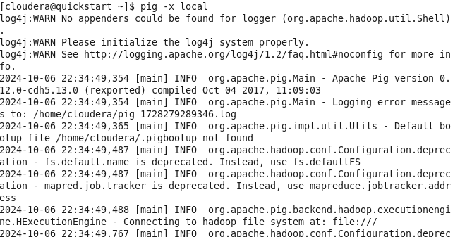

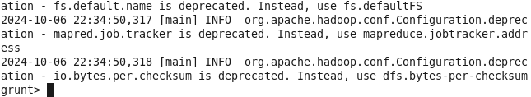

Load the command



* pig –x mapreduce

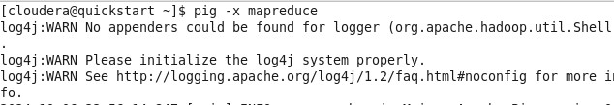

Load the command

